Boneless Beef Short Ribs and Polenta
Flour

Beef Short Ribs
2 lbs boneless beef short ribs (cut into four pieces)
2 medium onions into ½ in pieces
2 celery stalks thinly sliced
2 large carrots
3 garlic cloves
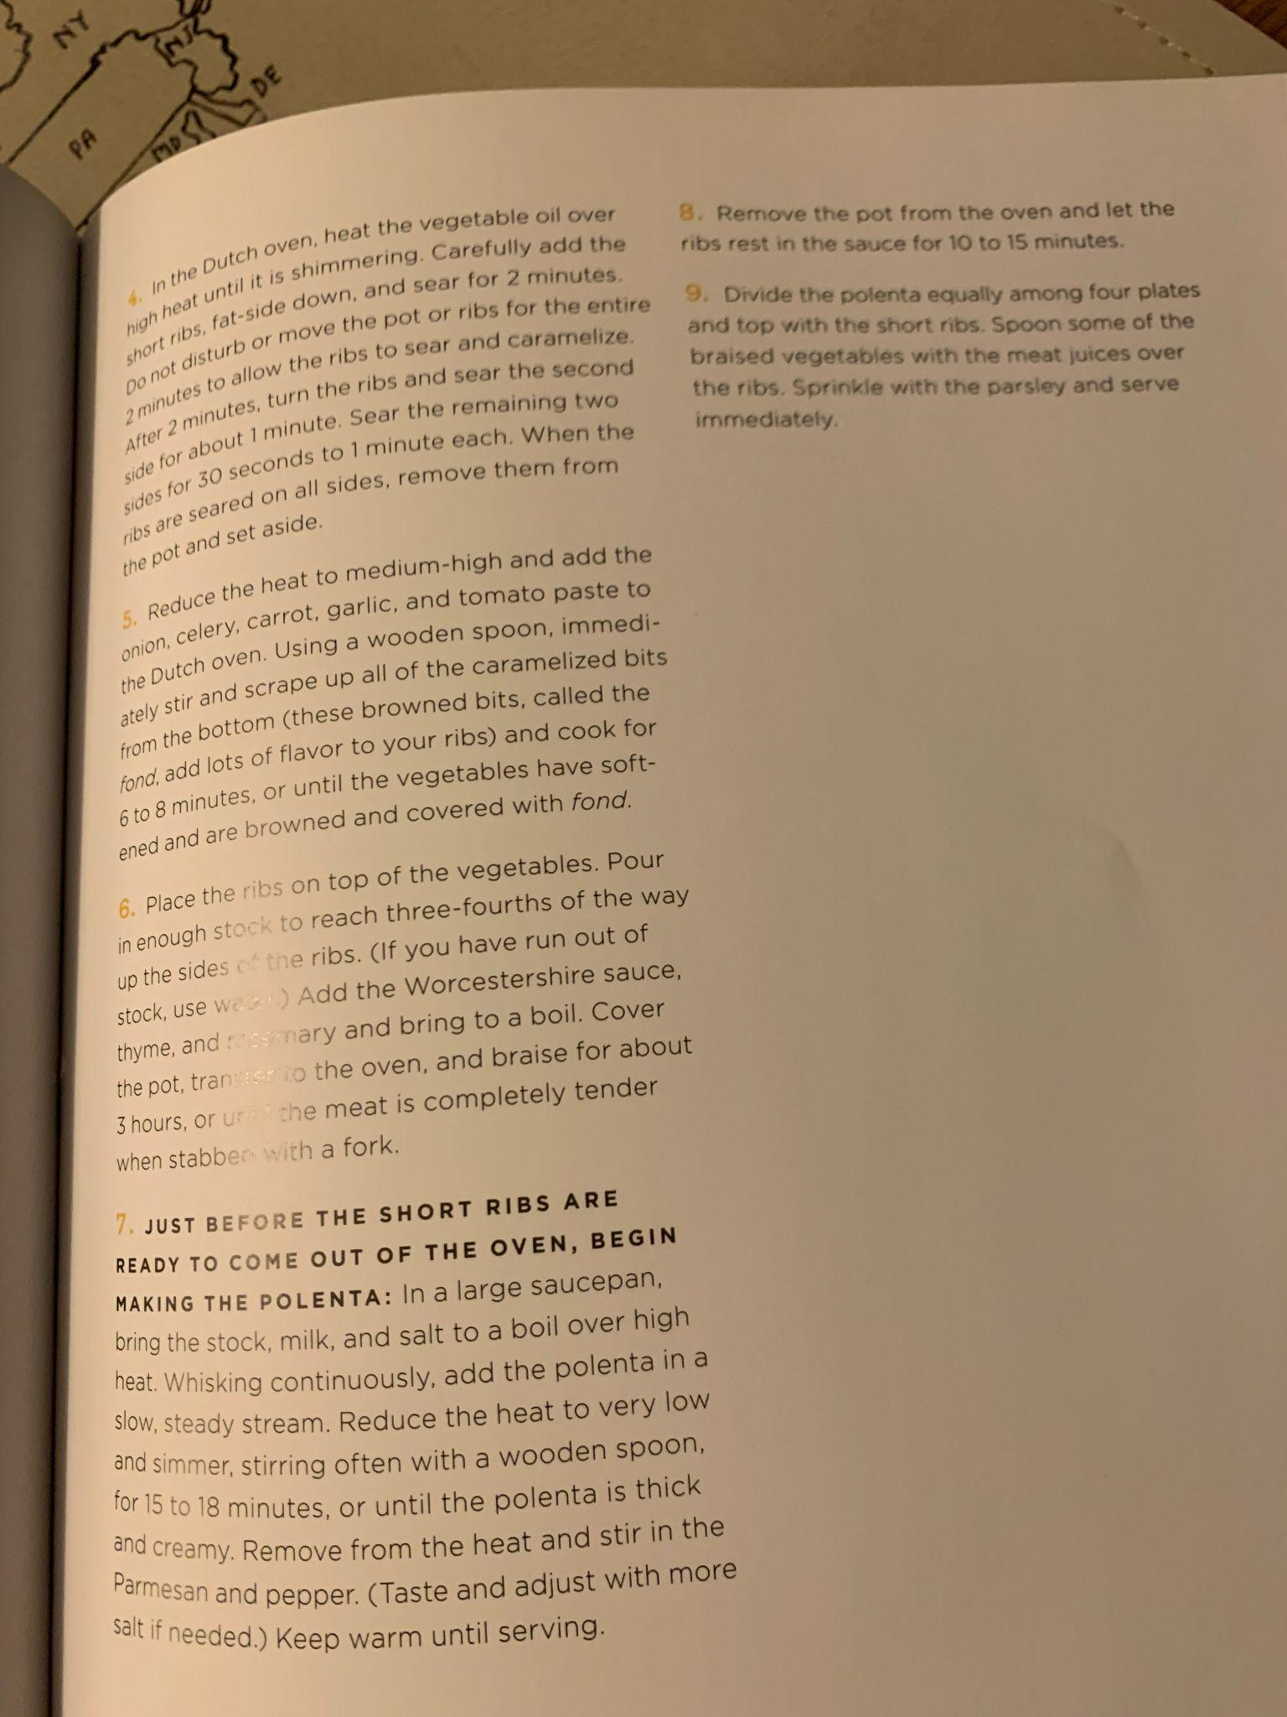
2 tbsp tomato paste
4 cups veg stock
1 Tbsp worcestershire s
2 thyme sprigs
1 rosemary sprig

Polenta
3 cups veg stock
2 cups whole milk
1 cup coarse ground polenta
1 cup parmesan
